Font | Times New Roman
Main Heading | 16pt (Bold)
Sub Heading | 14pt (Bold)
Content | 12pt (Normal)
Figure / Table Caption | 10pt (Normal)
Header | Project-I/II (Code) (Left Aligned)  Year-IT-Group ID (Right Aligned)
Footer | Page Number (Right Aligned)  Sir BPTI, Bhavnagar (Left Aligned)
Margin | Left, Right, Top, Bottom: 1.0” inch  Gutter: 0.2” inch

Front Page……………………………………………………………………………………..1
Certificate…………………………………………………..
Student Information Sheet
Acknowledgement
Abstract
List of Tables
List of figures
List of Symbols, Abbreviations
Index
- Introduction
  - Project Introduction / Profile + Company Profile
  - Purpose
  - Scope
- System Requirement Analysis
  - Current System Study
  - Weakness of Current System
  - Problem Identification / Definition
  - Requirement of New System
  - Feasibility Study
    - Technical
    - Economical
    - Operational
    - Schedule (Time Line Chart)
  - Development model used (Software Process Model)
  - Requirement Validation
  - Tools and Technology / Minimum Hardware and Software Requirements
  - System Architecture
  - Data Flow Diagram
  - Use –case Diagram
  - Activity Diagram
- System Design
  - Database Design
    - Data Dictionary
    - Entity-Relationship Diagram
  - GUI Design (Actual GUI Screen shot)
- System Development
  - Coding Standards
  - Tools Explanation
- Testing
  - Testing Strategy
  - Testing Methods
  - Test Cases
- Conclusion
  - Benefits
  - Limitations
  - Future Enhancements
Reference
Appendix
- User Manual
- Presentation (ppt)

Topic name
A project report
submitted by
STUDENT NAME (ENROLLMENT NO)
STUDENT NAME (ENROLLMENT NO)
In fulfilment for the award of the degree
of
DIPLOMA ENGINEERING
in
INFORMATION TECHNOLOGY
Guided by
FACULTY NAME


Sir Bhavsinhji Polytechnic Institute Bhavnagar
Gujarat Technological University, Ahmedabad
March, 2022

GUJARAT TECHNOLOGICAL UNIVERSITY AHMEDABAD
SIR BHAVSINHJI POLYTECHNIC INSTITUTE
BHAVNAGAR


Certificate

This is to certify that Mr./Ms. ____________________________ from Sir Bhavsinhji Polytechnic Institute, Bhavnagar College having Enrollment No: _______________ has completed Project Report having title ________________________________________________, individually/ in a group consisting of __ persons under the guidance of the faculty guide __________________________.

The mentor from industry for the project:
Name:

Industry:

Contact Details:

Institute Guide-UDP/Industry Guide-IDP Head of Department

STUDENT INFORMATION

Name of Student
Name of Student | Surname Name Father’s Name
Enrollment Number
Contact Numbers | Mob: | Land Line:
Email ID
College Name | Sir Bhavsinhji Polytechnic Institute, Bhavnagar |  | College Code: 649
Branch | Information Technology |  | Semester : VI
Student Team | Name |  | Enrollment Number
Student Signature

Sr No | Month | Week
1 | June | 04
2 | July | 04
3 | August | 04
4 | September | 05
5 | October | 02
6 | November | 01
7 | December | 05
8 | January | 04
9 | February | 04
10 | March | 03

4.1 Coding Standards and Guidelines
Different modules specified in the design document are coded in the Coding phase according to the module specification. Good software development organizations want their programmers to maintain to some well-defined and standard style of coding called coding standards. They usually make their own coding standards and guidelines depending on what suits their organization best and based on the types of software they develop. It is very important for the programmers to maintain the coding standards otherwise the code will be rejected during code review.
Purpose of Having Coding Standards:
- A coding standard gives a uniform appearance to the codes written by different engineers.
- It improves readability, and maintainability of the code and it reduces complexity also.
- It helps in code reuse and helps to detect error easily.
- It promotes sound programming practices and increases efficiency of the programmers.
Some of the coding standards are given below:
- Limited use of globals: These rules tell about which types of data that can be declared global and the data that can’t be.
- Standard headers for different modules: For better understanding and maintenance of the code, the header of different modules should follow some standard format and information. The header format must contain below things that is being used in various companies:
  - Name of the module
  - Date of module creation
  - Author of the module
  - Modification history
  - Synopsis of the module about what the module does
  - Different functions supported in the module along with their input output parameters
  - Global variables accessed or modified by the module
- Naming conventions for local variables, global variables, constants and functions:
Some of the naming conventions are given below:
  - Meaningful and understandable variables name helps anyone to understand the reason of using it.
  - Local variables should be named using camel case lettering starting with small letter (e.g. localData) whereas Global variables names should start with a capital letter (e.g. GlobalData). Constant names should be formed using capital letters only (e.g. CONSDATA).
  - It is better to avoid the use of digits in variable names.
  - The names of the function should be written in camel case starting with small letters.
  - The name of the function must describe the reason of using the function clearly and briefly.
- Indentation: Proper indentation is very important to increase the readability of the code. For making the code readable, programmers should use White spaces properly. Some of the spacing conventions are given below:
  - There must be a space after giving a comma between two function arguments.
  - Each nested block should be properly indented and spaced.
  - Proper Indentation should be there at the beginning and at the end of each block in the program.
  - All braces should start from a new line and the code following the end of braces also start from a new line.
- Error return values and exception handling conventions: All functions that encountering an error condition should either return a 0 or 1 for simplifying the debugging.
On the other hand, Coding guidelines give some general suggestions regarding the coding style that to be followed for the betterment of understandability and readability of the code. Some of the coding guidelines are given below :
- Avoid using a coding style that is too difficult to understand: Code should be easily understandable. The complex code makes maintenance and debugging difficult and expensive.
- Avoid using an identifier for multiple purposes: Each variable should be given a descriptive and meaningful name indicating the reason behind using it. This is not possible if an identifier is used for multiple purposes and thus it can lead to confusion to the reader. Moreover, it leads to more difficulty during future enhancements.
- Code should be well documented: The code should be properly commented for understanding easily. Comments regarding the statements increase the understandability of the code.
- Length of functions should not be very large: Lengthy functions are very difficult to understand. That’s why functions should be small enough to carry out small work and lengthy functions should be broken into small ones for completing small tasks.
- Try not to use GOTO statement: GOTO statement makes the program unstructured, thus it reduces the understandability of the program and also debugging becomes difficult.
Advantages of Coding Guidelines:
- Coding guidelines increase the efficiency of the software and reduces the development time.
- Coding guidelines help in detecting errors in the early phases, so it helps to reduce the extra cost incurred by the software project.
- If coding guidelines are maintained properly, then the software code increases readability and understandability thus it reduces the complexity of the code.
- It reduces the hidden cost for developing the software.

5.1 Testing Strategy
- Unit Testing
- Integration Testing
- Validation Testing
- System Testing
5.2 Testing Methods
- Black box Testing
- White box testing
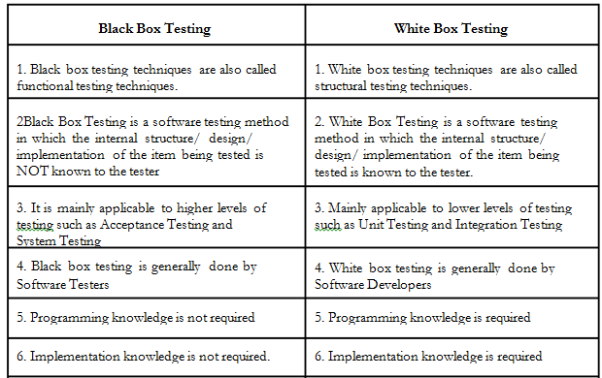
5.3 Test Cases (Minimum 5 to 10 Test cases are required)

